
School Of Engineering And Techonology

x Algorithm And Design Analysis

Submitted By ->
Name : Shashwat tripathi
Roll Number : 2401420025
Course :- B.Tech CSE (DS)
Semester : - IV
Department :- SOET

Submitted To :- DR. AARTI SANGWAN
Submission Date :- 9-April-2026
Course Code :- ENCS256

1.Backtracking Algorithms:-
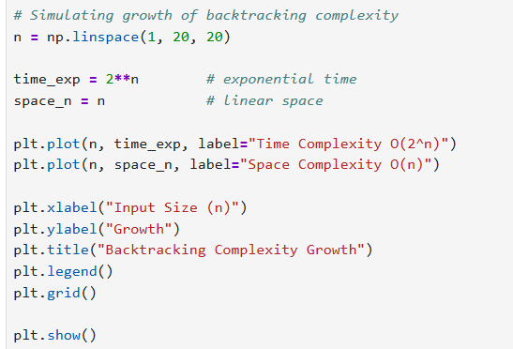
Output:-
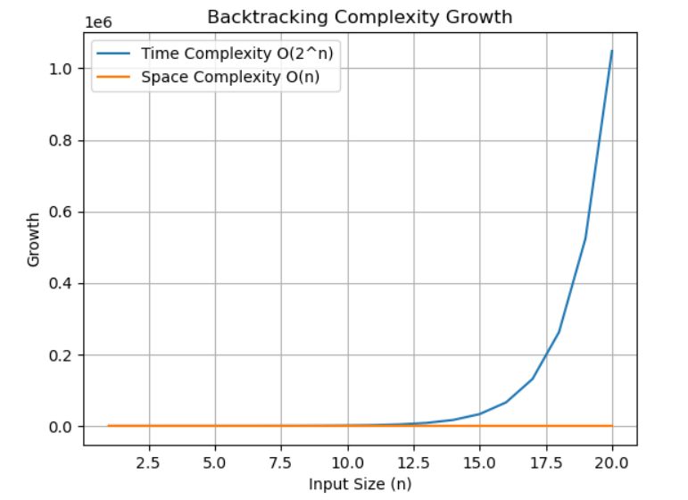

2.Branch and bound algorithms:-
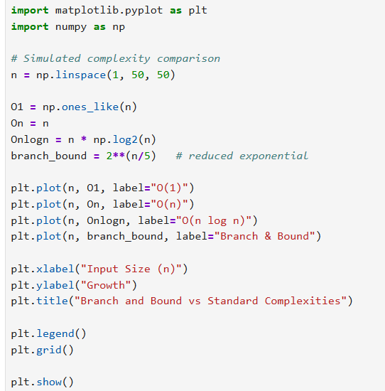
Output:-
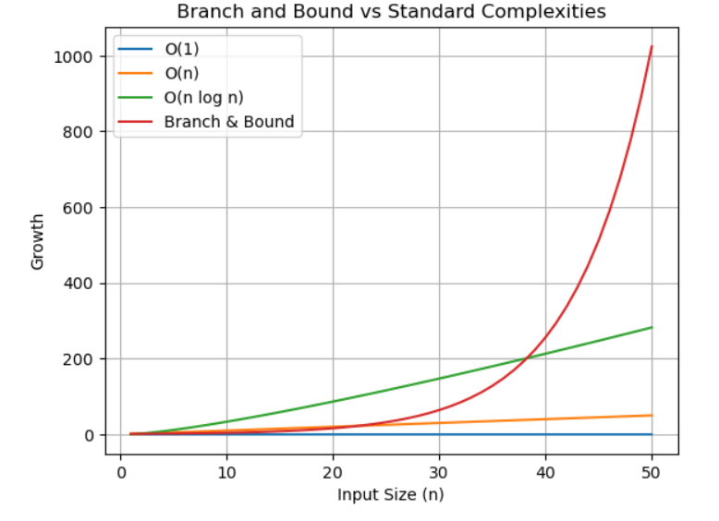

3. String Matching Algorithms:-
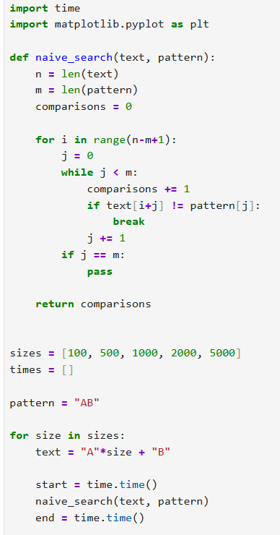
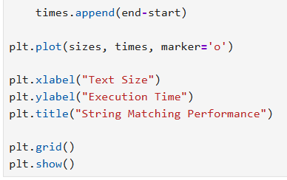

Output:-
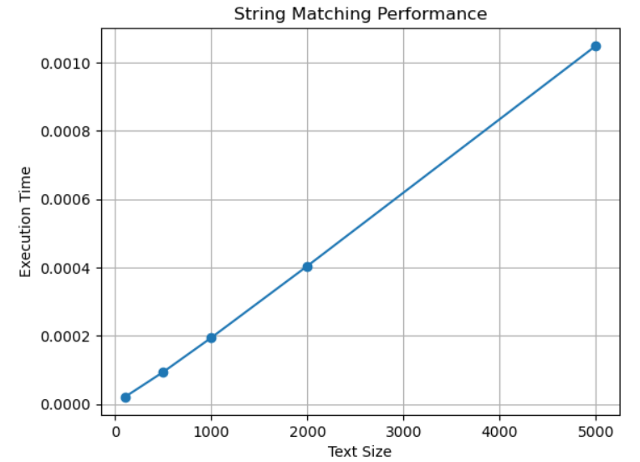

4. Experimental Comparison of String Matching :-
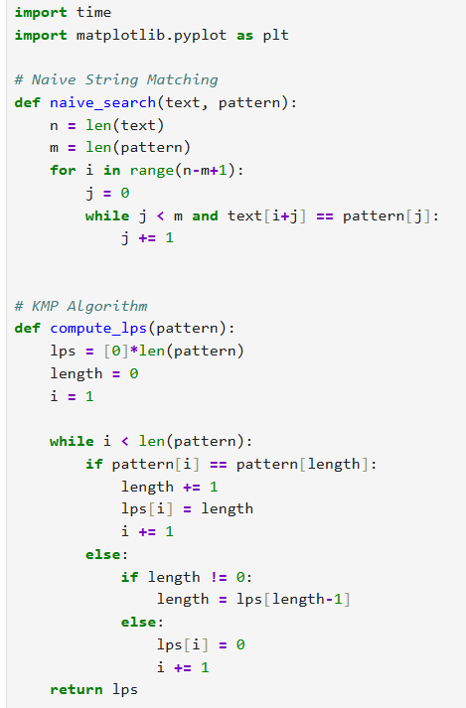

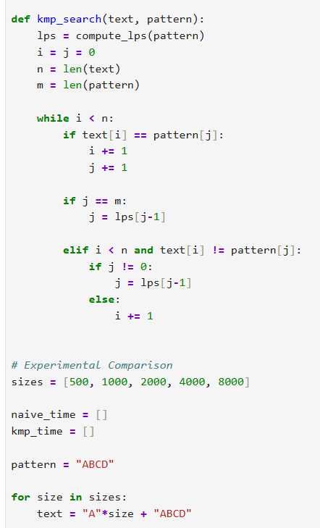
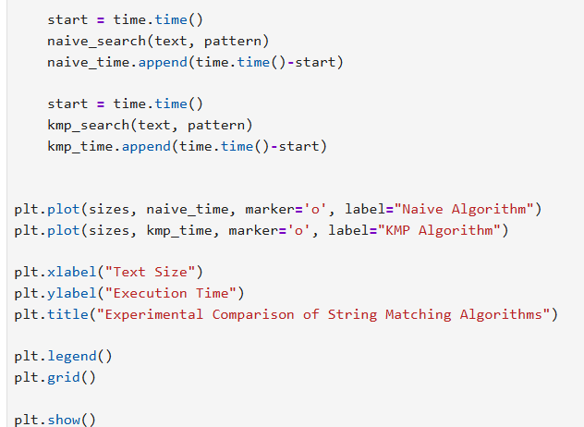
Output:-
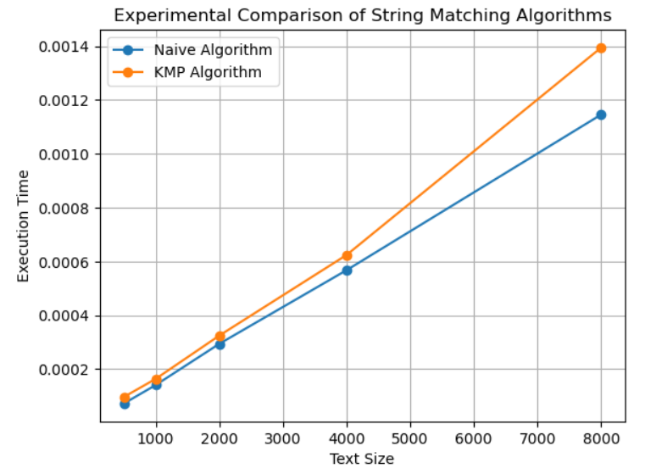

Github Link:- :-

